Written instructions on how to install and configure ScanDox when NOT using a physical scanner and just scanning digitally.
Installation of ScanDox will remain the same, however there’s an additional setup step required after at the workstation level. After installation of ScanDox is completed, follow these steps:
- Open window folder C:\
- Create a folder called Scanning
After the Scanning folder is created in C:\, test by opening ScanDox and following these steps:
- Upload PDF or JPG to Scanning folder
- Select the Scan to AbbaDox rule
- Select file from folder
  - 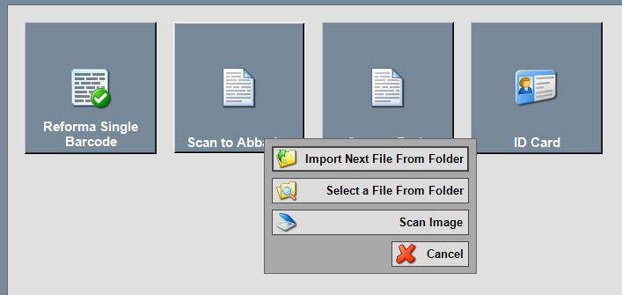
- Confirm list of documents in folder
- Select an image from left panel
  - 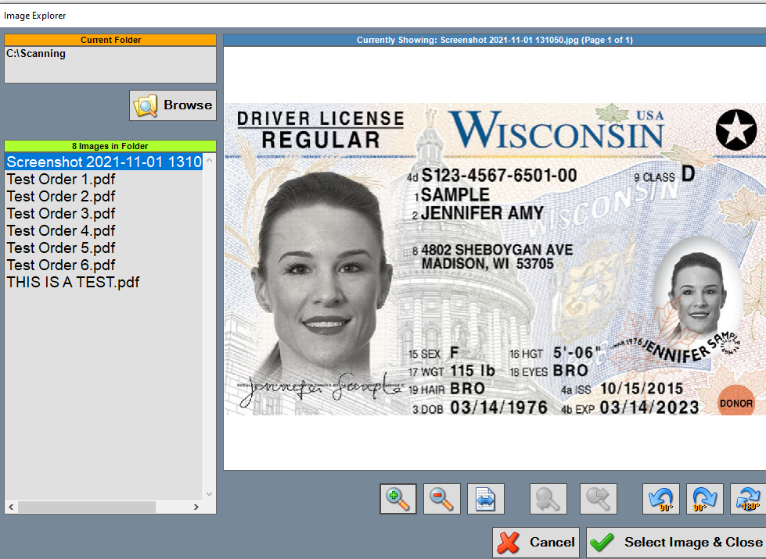
- Select Image and Close
- Proceed to file document in patient chart.

Written instructions on how to install and configure ScanDox to be able to scan digitally AND use a physical scanner on the same computer
After installation ScanDox is installed, and should the Scanning folder exist under C:\, no further steps are needed.
At this point, ScanDox will allow to scan digitally AND use a physical scanner on the same computer.

